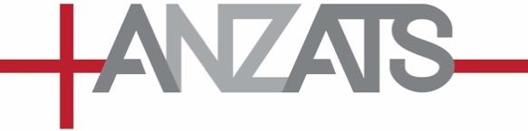
SAD NEWS — JIONE HAVEA
ANZATS shares in the mourning that marks the sad passing of Jione Havea.
Jione was a pioneering and inspirational scholar who will be deeply missed. His teaching and writing, and his support and mentoring of other scholars, were a precious gift to both the Church and to the Academy. Jione made a profound contribution to Biblical Studies in Australia, Aotearoa New Zealand, the Pacific, and more globally through the World Council of Churches.
https://www.oikoumene.org/news/wcc-mourns-jione-havea-prophet-of-the-pacific
Our sincere condolences to Jione’s family and especially to his wife, Prof. Monica J. Melanchthon, and their daughter Diya, at this time.
David
Professor David Tombs
ANZATS Vice-President (New Zealand)
April 2026

